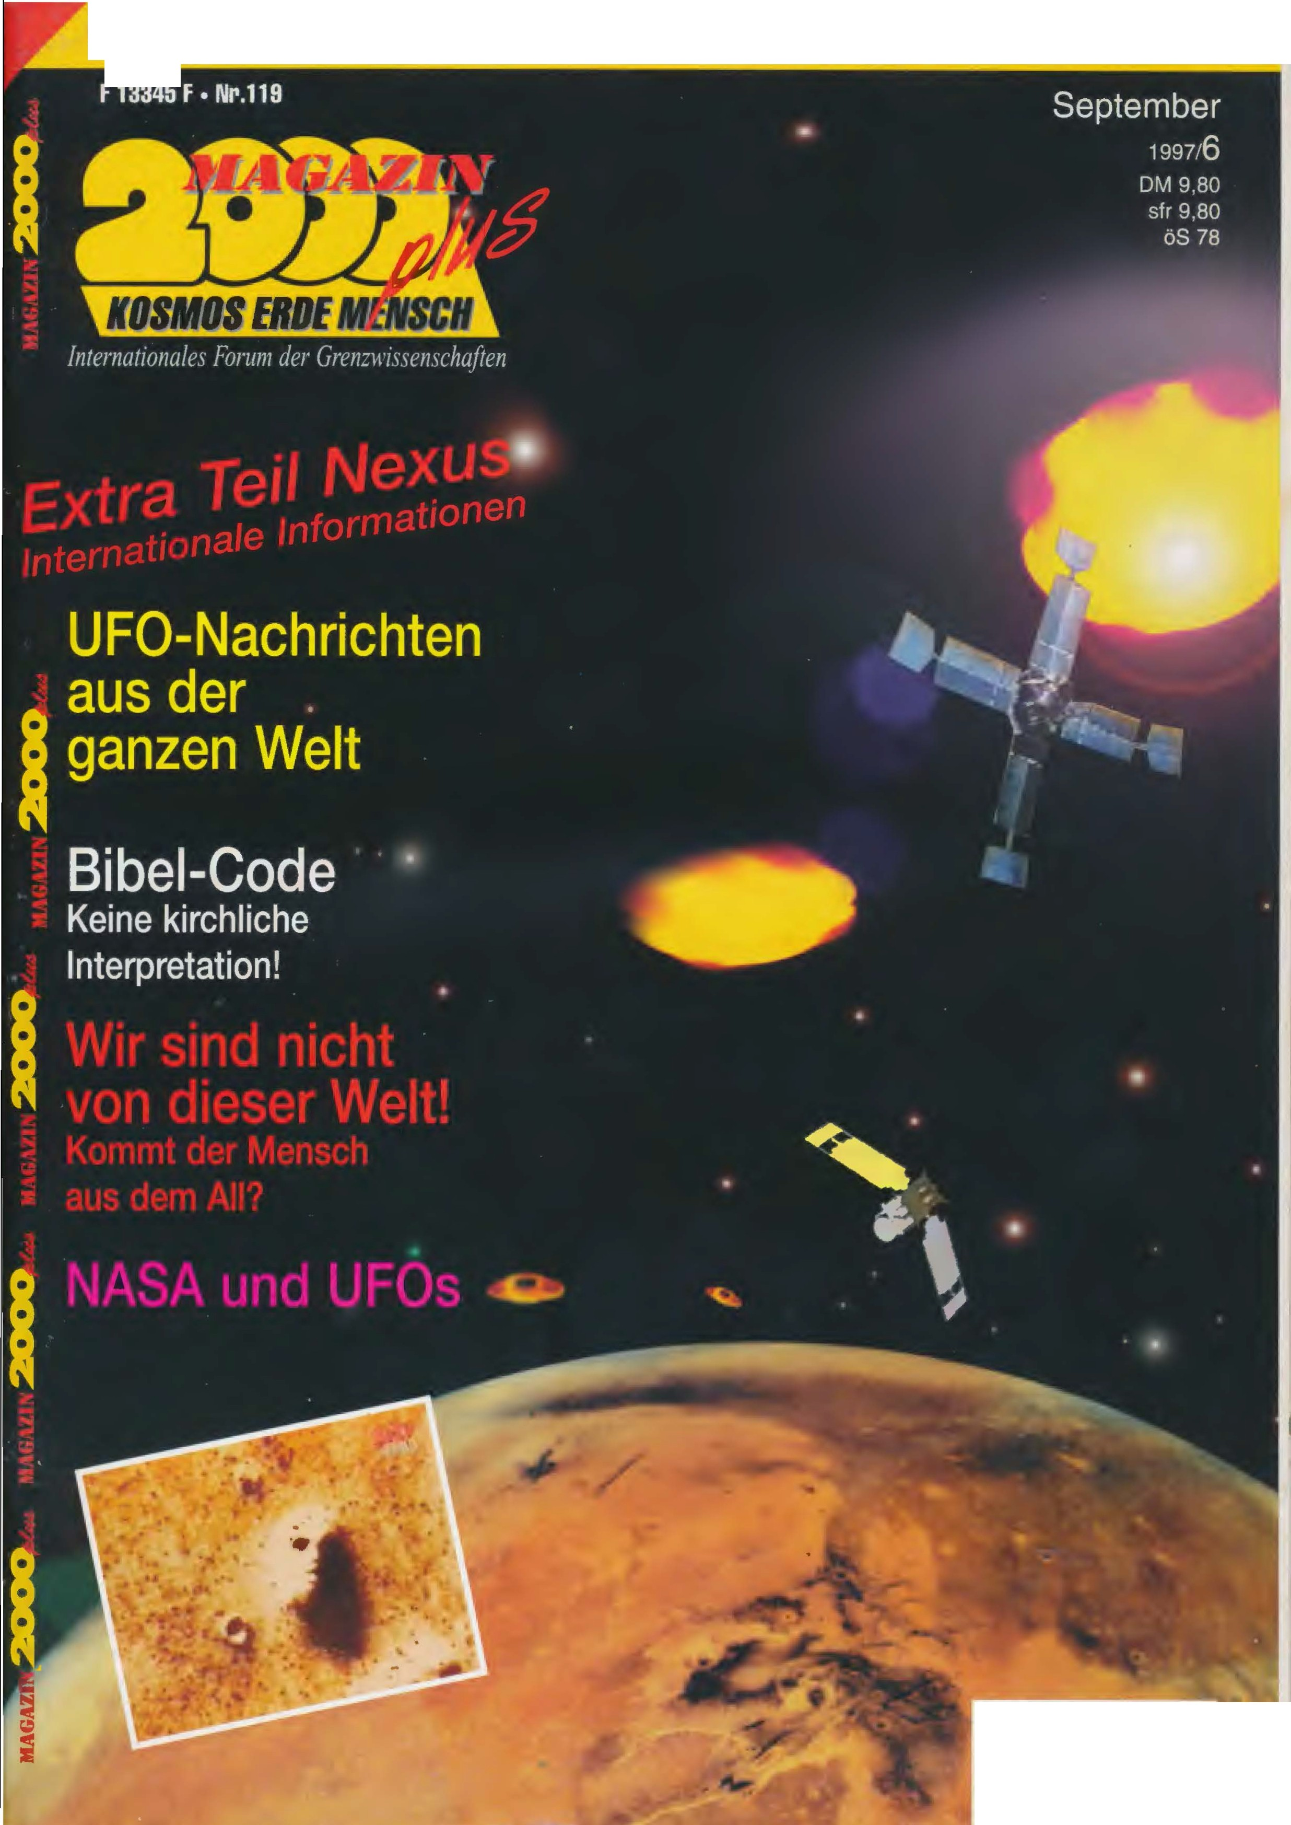
Our _ HISTORY _ _ _ _ _ _ _ • P l a n e t s system • M ay a -Astro n o m i e • W e llz e i t e r _ • newer _ _ moon _ _ _

00
II I'I I I I _ _
4 394041 lo . _ o . I

The _ _ RU W A Z i c h n f a l l _ _ _
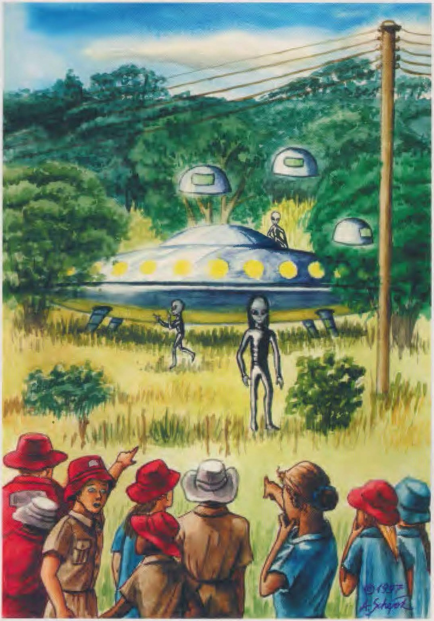
62
school · _ children r b e if · respect, think highly of U FO ·
landing _
continued _ out No. 118

FURTHER SIGHTINGS
the film records besta made me in addition, What rnir already trisha told would have: Daf3 some children already at the day before, to the 15 September
I anyway first at the Monday
to the school could return took I Cynthias invitation on: So to say as fee for think lecture _ would have you me to one Visit at the Victoria - Fall invited, one Nature wonder, the I Not miss wanted to.

THE SCH U LDIREC · GATE SPEAK _ _
Not all punctual, nope lich versus 9.15 watch - What me on think schooldays remembered - met I at the Mon Day morning in the Ariel school a. as first asked I Mr. _ Mackie around his com mentally to the prefill.
,,I stand the entire thing skeptical opposite", he cliir he me, ,,and think first reaction was: Well, maybe easy _ to have you What ge see, but leave we it there. Yet one Row from parents confronted me always again in order to. To to the entire process3, through the we went, and after to the prof mack at us was and the Schi.iler questioned, am

calculated 1994, in the large Pau see a UFO seen batten. the perhaps six witnesses described it as cigars fc: wrong and partially gliin zend. With trisha words :
,,I saf3 With some friend the and I saw this ob project at the heaven together With my Brothers, he was back then also on the (ariel-) School, he is since off gone, and it was how one Cigarette, and the End the Cigarette shone, and it floated at the heaven and disappeared easy." Two Further Girl described ben it me as ,,a UFO, the looked how a Airplane, but without wings, and it ver faded Behind one tree and came behind Not more out. "
Cynthia told me still from two further sightings in the Surroundings the ruwa
4 q Mogazi n 2000 / No. 119
Events, this time With he grow witnesses:
Alisa Stevens inhabited a farmhouse in immediate near the Ariel school and with direct View on the school grounds. On this
16 September cornice you early on. she rose out to the Bed, went to the Window, looked out in the dim merden Morning. ,,At the ser opportunity noticed I this glow about to the chicken coop", explained you cynthia, ,,I would have think glasses still Not put on, I fetched you, around see to be able, What the was . That glow would have one definite Shape, it was a very big3es, oranges Thing, the direct about to the chicken coop was standing. l fetched think Man, he should itself the also look at, yet as we again at the window were, was it
already disappeared. "
zara Vernon , one Teacher the ariel School, knew, daf3 the black driver the school one eerie Encounter would have, as he at the Day after the Landing, to the 17 September, versus 8:00 pm watch With to the school truck after home drove. Suddenly saw he Shape, which on the penalty 3e on him to move ten and the for him how
" dead " - apparently meant he skeletons - looked. He frightens wich he them out - and landed With to the Car in the penal ditch. Of the serve rif3 him after in front, With the forehead pra ll te he versus the Steering wheel, became conscious Come on. as he again to came climbed he so quickly he could out to the truck gene and ran back to the School.
Because it weekend was, and
I secure, daf3 the Schi.iler
definitive some seen Ha ben. l think, it were to a lot of, to to say, daf3 you defi positive a UFO saw but I am Celebration from that convinced daf3 you the truth to say. It consists the Possibility, daf3 some came and us - off which Found also always - visited.
Through the Visit from prof mack and his interviews With the children found we out daf3 some from them serious problems batten, the Adventure to to process. we batten a Child, the inside so upset was and With the entire situation Not finished became, and boy, 12 or 13 Years old, caught with bedwetting on, and unfortunately refuse ten itself his Parents, the situation With him to discu animals. His parents were

Der RUWA-Zwischenfall

very religious, and fi.ir you was it absolutely impossible, to accept, thatB her Son something like that experienced would have. she when theirs out, after Canada. " As others reacted Parents?
,,The most behaved rather neutral. only whole little came to me, around the thing to to discuss. I wrote the parents a Letter, beautiful because of entire media hype, the in the next week _ about
radar system to the questionable time except operation been be. That system was from one British company Installed been, so asked the reporter at the British message after, asked around Confirmation . the message contacted the Company, and the answer ten, it would have Perfect functional ned. Apparently would have man him so lied to why also always. Maybe wanted to the in Tower the just Not



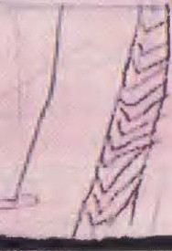

l WC\5
;'
)
It

us broke in . "
Lise/ mentioned there one Row from children the
admit. "

E N
around on the High School to walk, but nearly Everyone back then six- until ten year olds
built itself a trust stop on: as it to the Break rang, were Everyone children

feeling _ _ would have, the beings _ be came, around us before the Destruction the Earth to to warn. How _ _ stands it around the ecological _ _ Be be aware the School?
,,So, we are here of course very environmentally conscious, already because of location the sho le. but it is true, What Lisel Them told: A whole Row from children believed communications from the visitors received gene to to have. and the message was: stop the Earth in Order, cleans you, or you becomes Not more lan eng be."
To have the _ authorities for the incident / interested sed?
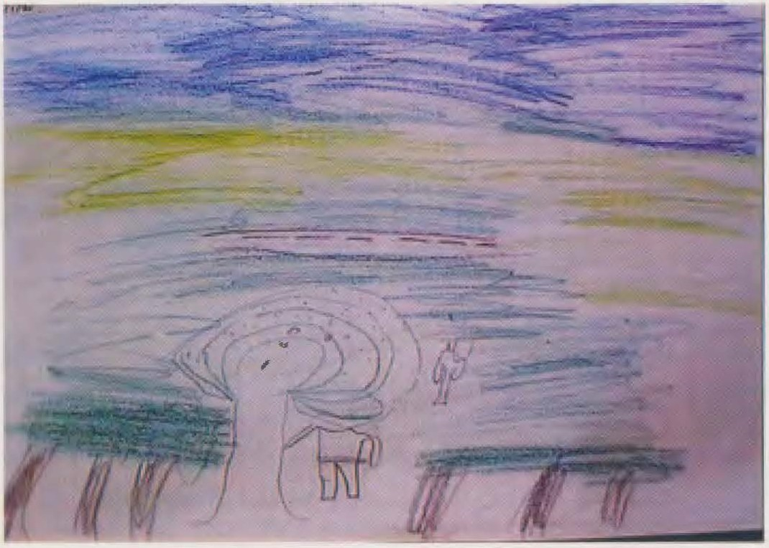
,,No, at all Not. but the bbc reporter, the beer was, asked at the Inter national Airport in Harare after, if man in the Tower _ some noticed would have. and the air traffic controllers in the tower _ explained you, thatB the
CLASS I M · MER FULL OF WITNESSES
After this we our Inter view completed had _ led

-;! l J J
- --

Friday _ " mr Mackie me in a seventh Class, in the itself the
most witnesses were. One row of children, the
back then eleven or twelve Years old were, had the school meanwhile leaving,
student were still there. I asked me short before, explain te the children, what I before would have: l would them one hour long Alles their Questions respond, and thereafter I would you request, rnir their

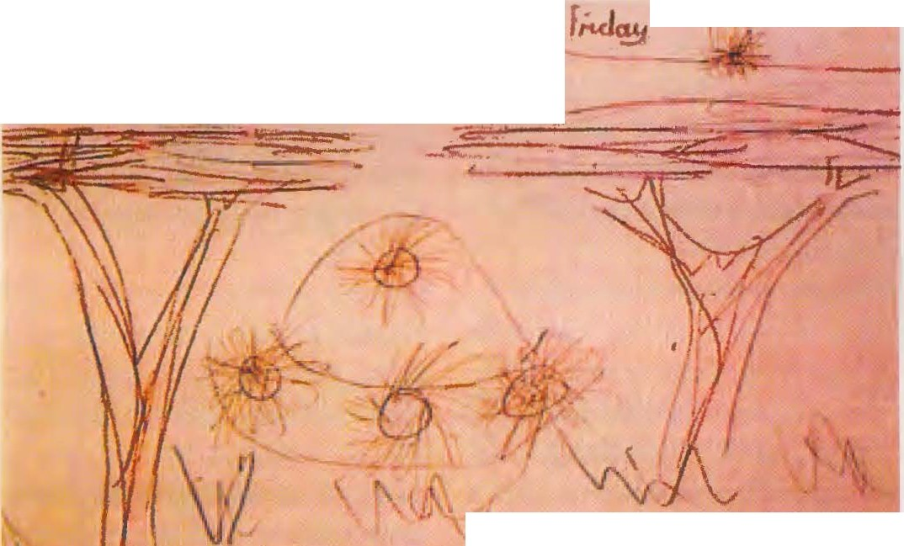
I

adventures from the 16 September calculated 1994 to describe. I asked, who from them back then there igcwesen was, and about 75% the 28 Schiller lifted the Hand.
until on a black mad chen, the just on a school assignment about German country worked - and to the I one English speaking bro shiire gave, the I at the Frankfurter Airport ge buys would have - wanted to you all more to the UFO theme he drive. rat I beautiful a times a sighting or Close encounter? Are the Except earthly one Threat? Are it kidnappings through aliens? I tried me, them the best anti words to give, and it
gladly ready, me interviews to give - you knew now, thatB I you serious feed
The critics, the me now witness tampering to throw be in advance said, thatB the children rnir Nothing told What you or others re Ariel children Not already three days _ after the Landing, at the 19 September 1994, to the BBC reporter explained had. Of the only Under parted was, thatB I one mush there spectrum from witnesses could speak namely overall 44 the 62 be shared Children, so Well two One-third. 17 from that saw only the spaceship - out the various Found, either, because the view from of their perspective from through the brushwood and the trees with special needs became, because she just Not enough approached or because you to small were and in the scramble Not Well enough see could - , 27 saw in addition the besat tongue member ever, either only one, two or - most - three. From _ further ten children lie me video recordings before, so thatB I all in all 54 testimonies evaluate could, from those 35 the humanoids mentioned. at both surveys one representative cross section tes from · procreate · were it 61-65%, the the crew mentioned. on the In total number from 62 witnesses vice
moiiocin 2000 No. 119 41

calculates means the: at least at least 38 the children to have the beings seen - one so far in the story of UFO research still never been there number from witnesses! 17 "mine" stuff gene (so 38.6% were June gene, 27 girl, from the l 0 from BBC interviewed children were 4 Boys (so 40%, What about to the school average ent speaks). I could so secure be, thatB I a good cross-section from stuff gene before me would have.
actually agreed their reports until in many details agree, during you in others points decided varied. That is perceive mental psychology explain bar, because everyone observer other priorities Has or tries, itself a rhyme on difficult recognizable de tails to make: After all happened itself the landing in Well l 00 meters Ent distance ! Despite it is a common basic pattern clear recognizable. So described all witnesses the spaceship as dome shaped, silver, shiny and strong reflective. Some added details how the wreath of lights around around the (implied) Dome, the substructure _ or even land fiiBe, during just young re and smaller children only the dome even recognize could. 10% the children - and that is those, the the landing site at the next came
- could in addition 4 until 5 small objects recognize, the in immediate near the big disc floated. Of the children, the the humanoids saw observed respected 40% Everyone three beings, 28% languages from
"several" crew member structure 24% recognized two, during 8th% only a humanoids turn off could. 50% the children he wanted expressly the big, black eyes, 72% saw thatB you a black, gHinzenden, hau-
42 Mogozin 2000 I No. m
tight men's suit carried. True apparently because of his shine, and because he the bright morning sun reflective animals, held I 6% him for silvery and 8th% for gol the. 12% recognized (either the at alien or at one the three ads the ,,Visit cher") one other Colour, namely red (8th%) or grin (4%) 32% the children who the humanoids saw believe, thatB the Visit took place around us before of destruction the Earth was too to.
Interesting is, thatB Not Everyone children the observed in the UFO context interpret th, there you - at least there times - Not once knew What UFO are. That is applicable into the special for very Boy, black Children: for you were the beings ,,small Monster" or To okolos
- goblins. So explained me one eight year old, black girl, the back then (with six) just the first class see visited:

where _ remember you you?
,,I remember me, thatB I something with black, sharp Zen Eyes saw, and it would have a black Men's suit, and there was this goidene (sic!) spaceship , and I saw, how itself the people there driing th, and so went I also, around to see, What it was. I thought, it was only a small no Monster."

What _ have you included recommended found?
,,I would have a little Fear." Saw it real out or rather how one Vision?
,,It looked not correct out."

Why?
,,Because I still never so some seen have."

Can you me more about the ,,small Monster" he to count?
,,It moved itself a little slowly . It went as a albemes old one beings."

and the spaceship!?
,,It was around and it was golden and it would have lights on the top."
That girl was by the way
the only Child, the the disc as ,,golden" be wrote. Probably ent was standing this impression because of the strengthen reflection .

and so described the children the from Ruwa their sighting:

THE SPACESHIP:

,,We played on the
'Jungle gym' (so to name the children the scaffolding on to the Playground), pli:litz saw I, how the whole school ran off. I looked after and asked, What Come on was, and Everyone shouted only some from 'alien' or so. and I looked there over, and I saw some metalli she and the Sun seemed on it, and it was from one Row lights surround." Derrel Thompson (12)

,,It was rough and silver and glittered."
Cameron McPherson ( 11)

,,Around on the top and flat on the bottom and silvery"
phobe Haley Lindatt (I 1)

,,That spaceship was flat and silver and would have so a round thing on the upper page, the is, Where you sat, before you came down." Emma barbara newland (10)

,,It was a spaceship, and it was from one ring surround. It shone, glinz te strong."
amy Olivia (10)

,,I saw a silver luminous object, the on to the floor was standing. It looked from like one big silver hubcap . That was, What I saw. It was shiny, gliin zend, how if man one hubcap polished (ie how polished Chrome, MH)."
ian watson (14)

,,A silver mes object glide smashed there over there in the Bush." Bradley robins (12) and
Bryan Clark (13)

,,What I saw was some, the how a more metallic rocks looked like it glowed and was from Alles this Lichtem around give."
Struply (9)

,,It was how a Mirror, it reflected the Sun, and we looked it us more accurate on and saw thatB it the shape two stacked he places saucers would have, and it was silver."
John wheeler ( I 2)

,,I remember me, thatB I a spaceship saw, the the shape one saucer would have, and it saw so as, ais befan the itself small things around."
Tamarishka skayne (I I )

,,I saw a silver mes thing with lights on the upper flee. she had various those Colours. It saw out how a frisbee and would have one light dome on the
. top."
IE slounga ( I 0)

,,That object was silver and very bright. It was when be it poied been, in order to it beautiful hinzt, and it did the children in the Eyes sore, some the big caught to cry on, and the object was so rough ... about 15 meter long."
cary Evans ( II )

,,A spaceship with light tern around."
karen Stone (10)
,,The spaceship would have the

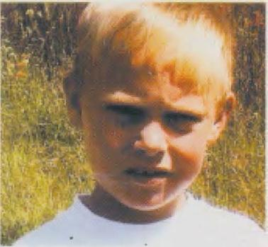
shape one rocks. It moved itself Not. First as lights to flash began-

Der RUWA-Zwischenfall

no, rose it from the floor on."
craig Alcon (9)
,,A spaceship , bright ,

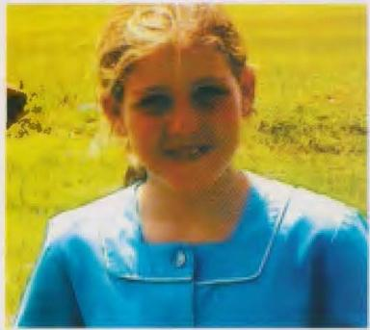

bright Silver ... and many small ones. "
Ashley bowl (11)

,,Four or five small If projects flew hereabouts , stood a meter above that floor and disappeared." Emma Christensen (13)

,,It disappeared like m one Lightning."
ann McBarrow (12)

THE OCCUPIERS:

,,I played at the show cling and I saw, how everyone to to the dam ran, so laid I my lunch packet there and looked after, and as I there came, saw I the ses yellow thing at the trees and then saw I this People, you carried black Things, and you jumped from the top one saucer down,

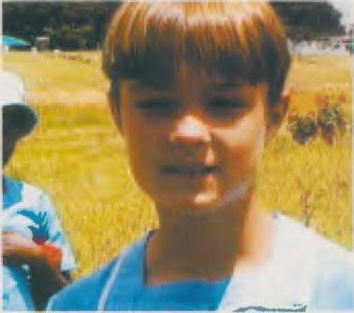
and you were how normal People, but you went so funny, and I would have scared , _ I knew Not, What you were, I would have fear and was simultaneously lucky lich."
Charlene scummers (9)
,,I saw this shiny
Thing, What there at to the rock landed was, and me saw, how people there came out and I remember me on a whistle . I saw, how one came out then saw I a Behind a tree walk and I dared me closer approach, around nachzuse hey, and I saw, dal3 it aliens were, but I could te it Not believe, because I so some still never before seen have. l would have no Fear, I thought at all Not about it after. It saw all real out."
derel Mafouto (9)
,,A syllables, round thing and three at the heaven and three black objects, the there walking around she batten grol3e Eyes how cats eyes and were really thin and grol3."
Camilla russell ( 11)

,,One kind spaceship, on to the one black person sal3."
Kelly van douts ( 11)
,,I saw one person _ the on the top of ship sal3, and one other , the walking around as be you ver confuses He ran on us to and again back. He would have about our size. he was black and would have long Hair. He was very thin." ann McBarrow (13)

,,One sal3 on to the silver thing in the Tree Group and a another ran there and here. He was nearly how one normal painter human , but he was very dirr. First thought I, it be a black Young, but be hair was more like our hair (so smooth), Not curly."
Daniel mandy (14)
,,I saw a small black Man With long black hair and growl, black Eyes. He turned itself to us around, looked us on, and turn to the Ship back. His Eyes were oval."
amy Horton (13)
,,He wore a shiny,
black Men's suit, how a wet suit. He was very closely. I saw be face only short. I because3 only, dal3 his Eyes black were." Emma Christensen (b)

,,And I saw this black Zen things, the there lying around fen and you had big heads and Eyes how big ful3balle. Aile shouted:
,Looks You the Eyes on' and so looked I also, and the Body, the would have the color one black swimsuit. "
Derrel Thompson (12)
,,We saw small black

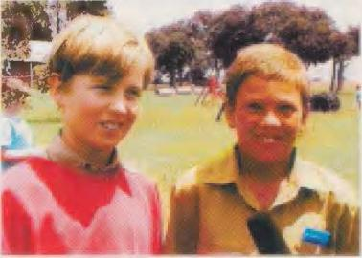

beings _ the there walked around. she saw so off , as batten you short antennas and big heads , and you were Law small and about on the Height of aircraft . " bradley Robin's (12) and Bryan Clark (13)
,,I saw one shape , the

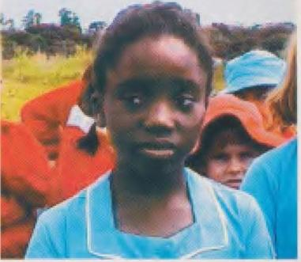

all black was. And inside would have you a Hole or some dark, dark black, vicinity the hair. I could no face see, only dark s , dark Black".
angela Mercury (10)

,,Two came out of here and one sal3 on the upper area"
phones Haley Lindatt (11)
,,The beings _ carried black

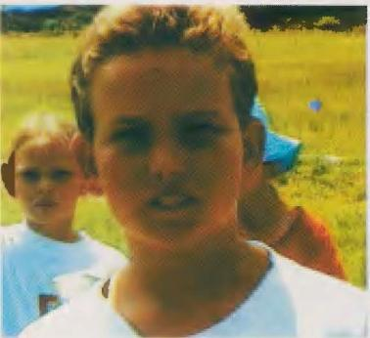
ad e . . . you moved itself very slow. It were three."
Daniel russell ( 10)

,,I saw three aliens, two in silvery ads , _ one in Gold. she went Behind a tree and then ver disappeared she . _ There were three lightning."
Emma barbara newland (10)

,,This three people looked Not very kind out. one saB on to the spaceship. The beings _ were Everyone black. Small things came from theirs heads . "
craig Alcon (9)

,,I saw some With black Zen, sharpen ears and it would have a black Men's suit, and there was this gol those spaceship. . . I top, roof te, it be a small Mon ster. I had Fear. It looked not correct out, because I so some still never seen have. It moved itself a little slow. It went how a albemes old one beings . " small black Girl (9)

,,I saw two beings, you were small, very small and batten big heads. And you had _ I saw a couple A details, very small noses and big Eyes. she were Not so far removed."
amy Olivia (10)

,,That extraterrestrial something was already dropped out (as I it saw) . It was black , and man could be face Not really see, it would have the color .of ours keep (so reddish). Man could the face Not really recognize. It was Not too grol3 and Not especially
#.o),Jalil 2000 / Nt.119 43

Der RUWA·Zwischenfall

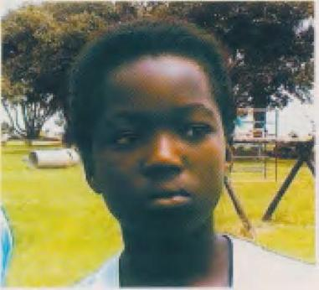

small, somewhere in the Center. I believe, I have his Legs and Hands recognized." Nguano Njuaowe (12)

,,I saw aliens one was grin With big, black Eyes. one saB on the Top of spaceship, the other came before one tree down."
Tpora Regita (I 0)

,,Three Men sat on one spaceship."
Tara Krueger (9)

,,I saw three Men and one was in Black dressed de and one was in Silver dressed and the other ( third ) wore Black." Nickla alcorn (8th)

,,I saw three Persons, and I think, it are Except earthly. Two carried a golden Men's suit, one a black. l saw, how you in one flash ver disappeared and then saw I Nothing more. she batten about think size (approx. 1 m, MH). First thought I, it be People, but then saw I their big, scrape eyes." Ptemba Touranda

,,A alien was black and two were red. she went hereabouts, and one sat itself. she went so funny." karen Stone (I 0)

,,As a black, the at to the tree was standing, but he was ugly, very ugly and had black cats eyes, Eyes how one cat ze, but black. It move te itself very slow, how in slow motion, as were it a Robot, the man Not oiled would have, so slow, thatB we
44 Mogozin 2000 I No. 119

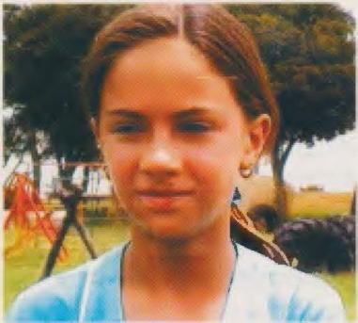
sometimes not see could th, if it itself at all be away or Not."
Elaine leah (12)

,,She . walked hereabouts. Man could see, how their ribs stood out you were so ugly. she batten a long face and Eyes how one Cat. she gin gene how in slow motion. one ran around the spaceship hereabouts."
Ashley bowl (11)

,,And he was very thin, he wore some how a black Zen Ski suit, how narrow, narrow Plastic. if man longer looked, did it the Eyes sore, so bright was the Day. then saw (we) this black (beings) With crossed poor and With one shoulder on the tree leaning. (The beings) were ugly, dilrr, very, very dilrr, man could their Bone see. Of the size was standing, man could his ribs see, because the Men's suit, the he carried, so closely was."
cary Evans (11)

THE MESSAGE:
,,I think, you batten one message fti.r us."
Tara Krueger (9)
,,Maybe happened it

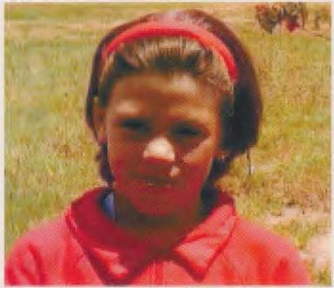

because the pollution . here is it everywhere dirt umpteen."
Brynie mcomick (9)

,,I heard in the Night before one kind Explosion, and my first Thought was, thatB her planet explode died and the the reason was why you to the Earth came."
amy Olivia (10)

,,I think, you came, because we so very the World packed sten and you came, around us to to warn."
doana Christopher (11)

,,Because in Zimbabwe all so dirty and dirty is, perhaps came you, around us because of gauzes and so to to warn."
Derrel Thompson (12)

,,I thought, you wild us perhaps attack, because we any some not correct did batten or some have destroyed the for you valuable was. Some people believed thatB the aliens came, around us to warm, because the Earth destroyed would."
Cary Evans (11)

,,She wanted to our Earth to study, and perhaps to have we some not correct ge power."
Ashley bowl (11)

,,I believe, you tried With us to communicate. she wanted to us some to say. l believe, you wanted to us to say, thatB some happen becomes. I think, you to have us select. she showed us some, on the other people Not believe." Candice Albasin (14)

THE AFTERPLAY:
,, We went With ours Teacher (on the Job). There lay dead Bird hereabouts, Where the UFO landed was. and we saw so one kind footbab press the Animals and foot print the aliens and the grass was standing still, but it was somehow down
presses as be some over there gone. Some the seventh kliissler in that Year gin gene also With one teacher there, and you said you batten burn marks and dead ants discovered."
Charlene scammers (9)

,,I thought, you come in my Bedroom."
Ptembah Touranda (8th)

,,I cornice in the middle in the Night on, because I a nightmare would have, and there were circles, purple and blue, and triangles, orange and red, at the Wall. l cornice on and rubbed me the Eyes, because I first top, roof te, I dreamed but I dreamed Not. I told mine mother of it, but the believed only, I will Nonsense tell."
Elaine leah (12)

,,Three days thereafter found I a purple object on the wall, the thing came on think Wall, I lay still in the Bed, I could think Legs Not move. we found out of here, thatB the window was open, and I told mine Mother, we batten aliens in the house had, but you could me Not believe."
cary Evans (11)
(The interviews With the today 13- and 14 year old children came from out the B B C - A and f e.g e i ch n and n gen _ . All children were to the time the sighting of course two and a half Years younger)

SCORING
I have the shape this conscious comparison more literal quotes ge chooses, around to clarify, how far indeed the descriptions the children from Ruwa agree. All quotes are word literally, there I all off to say for one future film documentation on Video (in one professional nell Format) recorded men have. Around full-

Der RUWA·Zwischenfall

re Testify to get as those, the man on one Late morning cinematic documentary mention can, asked I all concerned Children, me her Adventure in everyone details in written form to describe. I hope, thatB their Essays in the next weeks _ at me arrive will. Only so is guaranteed _ thatB this important, Yes downright historical UFO case sufficient for the posterity documented becomes.

WHAT I ST HAPPEN?
To one spectacular sighting wave about to the entire south Africa in connection _ With one satellite litenteil re-entry at the
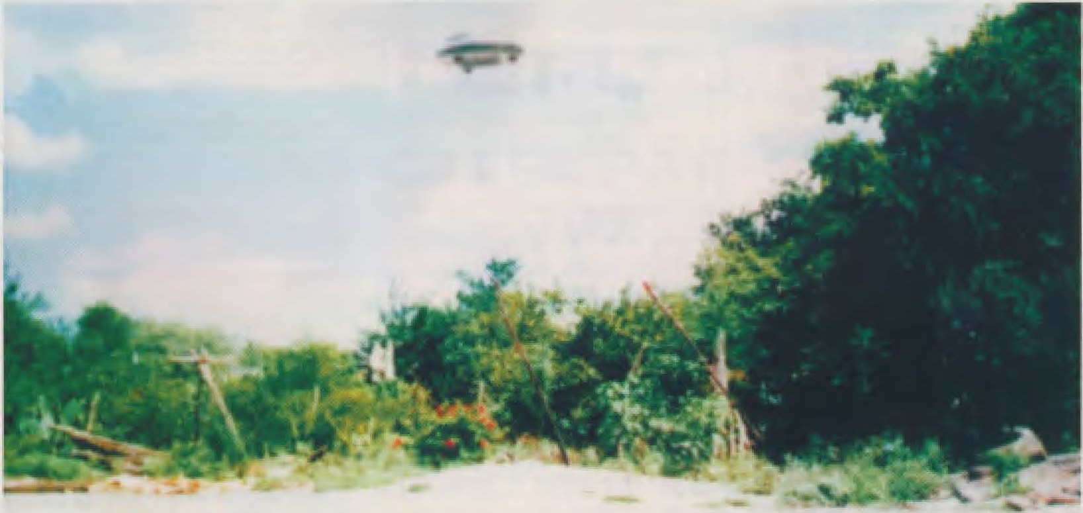
14 September has apparently a cigar-shaped spaceship _ at the 15 . September the situation at the Ariel school scouted, before man at the 16 September over, on time to the large Break, to the landing on sat. It was Nothing small clear as a first more open contact with one out elected population group, the same two interesting characteristics _ exhibited: she was multicultural real and multiracial - and it were Children. who _ also always the landing orchestrated, he wanted to sat hen will - he landed to one Time, to to the Everyone children on to the breaks court were. He wanted to a certain Distance - he went sure , thatB a swamp and the thicket the children from that held to vicinity to grain. and he wanted to only children reach: He chose of all things those Break, on the Everyone teacher to one con reference in staffroom gathered were. the landing _ took, the shields ments the children according to in between 3 and 5 minutes, was so long enough to details to make out but
fen, but mine opinion after sees Alles this how a perfect one staging off . Apparently would have someone an isolated one target group selected, how man you better nowhere find otherwise could: One lonely school literally at the End the world , nearly in the middle in the Bush, from forest and pastures _ around give, in one Country, the Not just in the center of public interest stands. the target group were Children, the as microcosm (nearly) Everyone races the Earth embodied. Children, the intelligent and open were enough the situation to handle. Children, the hardly better as test group for an experiment to serve could, how the Boy generation of planets Earth on a contact With aliens react would. (Interest kindly were also 1989 in Voronezh the key witnesses Children.) the children to have the exam _ so believe I, passed . who failed were their Parents, the it preferred the head in the sand to put and the Adventure of their children to to ignore. What saw the Children? Apparently a landed spaceship and (until to) three inmates. I asked each separate Child, if the happened
rather one vision equaled or real was, so real how to the example one helicopter plane dung (I hope, thatB this pure example Not again from professional UFO skeptics picked up will the probably beautiful thereon waiting, out to the Ruwa case one misinterpreted helicopter landing to make). With three Out of took answered Everyone, it be absolutely been real. Those, the rather on one vision believed gifts as single reason on, thatB you
,,so some still never seen" to have.
It was a long time ago afternoon , _ versus 15.30 Watch, as I the interviews With the children completed would have. I would have you Everyone somehow in my heart closed , and I think both pages Has it fun did. Nearly a little melancholy said goodbye I me from those children, the until now with me ge stayed were, around me to help. A moment long did it me suffering, Not teacher become to be, to minimum on this school With their so bright and nice children . A long time ago was standing the school sport on to the afternoon hours plan, one resolute Sports Teacher trained ,,think Class" in the Hockey, wah-
ren mr Mackie on to the sports ground for one Further class the time at the jump ten stopped. I agree divorced me from him, ver spoke, in Contact to lead ben. With one medium heavy ren sunburn after the hours interviews on to the schoolyard drove I back after Harare , Where Cynthia on me was waiting, the it itself Not let take me personally to the Airport to bring. I would have enough Time, the case still once revue passie ren to to let, and towards think about the memorable gene events of 16 Sep tembers 1994 Then What back then in Ruwa happened _ _ was Not once a single case...

THE E MEX I CAN IS _ _ _ C ONNECTION
Nearly contemporaneous With the He happen from Ruwa came it literally at the others End the world , in Metepec west from Mexico City, to one Not less spec tacular Incident. (please refer MAGAZINE 2000 No. 111)
At the 15 September 1994 versus 8:00 pm watch local time
- in Zimbabwe was it be ride the 16 . September 5.00 watch early - observed hundreds residents from

to short, as thatB the teacher fetched will could ten. I can me Not hel-
UFO about Montemorelos, Nuevo Leon/Mexico, from the Summer 1994, photo from Pepe Martinez. Two Ruwa witnesses meant because the dome shape and the extreme rejecting surface the of at their succeeded dead school corresponded only d a .P ,,her" UFO no hemispheres up the underside i te would have.

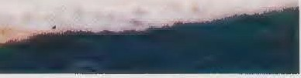
Mugozio 2000 / No. 119 4 5

Of the RUWA incident _ _ _ _
company

New Motifs :

metepec, how one disc from perhaps 25 meters diameter in about 200

early was, the school bell to big Break was.
Regrettably are it

Socorro , Varg i n ha, 54
- *

meters Height about one cornfield at the suburban floated. Two small, Red diamonds ,,how flashing slide manten" shot out to the object and swirled <lurch the cornfield. you _ moved itself so quickly, thatB it out saw, as would you only blind know . then returned you to to the Ship back, flew Ahead to the Metepec Hill, followed from the big
Disc, around itself there With her
from to the incident _ no Movie recording n . One witness Sara cuevas, would have their vi deodorant camera fetched, <hole the camera electronics failed. as you her Man, one German Engineer, from to the incident _ told, could he his Woman Not believe . Insulted decided Sara, the evidence to the contrary to compete the camera in the attack laid you itself the next
evening on the lurking court
th E C> RI c:;;. I N .A.L _
AN1MANoNAcESSOR 1 It NEW : delivery in _
Germany and Austria away warehouse Austria without Customs surcharge _ _ _ _ _
' l' OP UUALl 1 ' i\ . 1 ', G IJ'fES _ _ ltESIGN
A U E All ' fllEL IN SEHll LDll'l'IEl l' l' Ell _ _ _ AIWIAGE

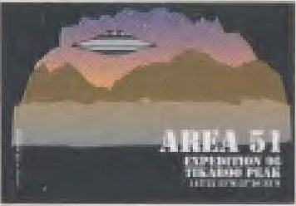
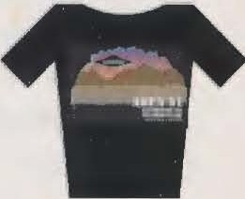
AllEA51
D t shirt L
D t shirt XL
D Ba s e Ball cap
D C o m p u t e r suitcase
c

to unite Two hours later dived the object high about to the field again on. As local residents be judged, came seven small no discs, every perhaps
50 centimeter in the Through knife, out to the big spaceship and shot With bigger speed
<lurch the cornfield, in to the you a sample out flat

That play took ten
fend, thatB the UFO back sweep would.
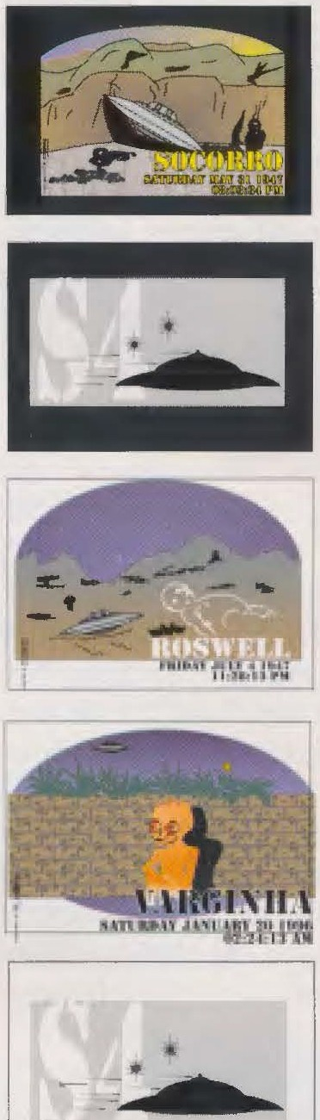
It came Not. Instead noticed Woman Cuevas versus
21.00 watch in the presence of their sister Erika, the her Company jeisted, a glowing Dwarf, the in only 60 meters distance out to the nothing in to the Corn - pattern showed up and it apparently inspected be

the disappeared.
SOCCOllO
D t shirt L
D t shirt XL 0
D Baseball Cap Cl.
S l t SCHWAllZ :::J
D t shirt L
0
D t shirt XL
u
D Base - Ball _ cap
llOSWELL I
-
0 t shirt L

put plants formed.
minutes and became from
before he just as obligatory how
Consists a context
0 t shirt
XL -

dozens witnesses breathless
tracked. the small shit ben came until ten meter on the Houses approach. Out of them shot dog died smaller bullets, Eyes similar, the itself short term to feet the corn plants never loved _ around seconds long the whole Field daylight to illuminate, before you how the disappeared. now bra chen People, the the spooky play be observed in tears _ off, others screamed hysterically, while again other how paralyzed to the silent spectacle attended. Finally returned the slices again to to the
in between the prefill _ from Ruwa and Metepec? In at the traps became a cup furry spaceship ge see, the from several smaller companions vice ben was - the description gene voices in many details agree (With to the Main difference thatB the disc in Ruwa at Day be watched became and silvery shone , while the
Metepec UFO in the Night Red orange glowed. That but
Prelse
Schweiz Oesterreich Deutschland
T Shirts Caps
Comp.Koffer
sfr 39.-- sfr 19. · sfr 39.­
os 375.-- os 179.-- os 375.-­
dm 43.- dm 21.-· dm 43.-
ln Deutschland wird die MWST von def Post ein
Versand
sfr 6.­
os 50.
dm 8.-
is for UFO Apparitions typical) fact is: Out of the annals the UFO For ing becomes the 16 September calculated 1994 Not more away
D Baseball Cap Q)
D computer suitcase +"'
VAllGINHA t/J
D t shirt LQ )
D t shirt XL
D Baseball Cap cc
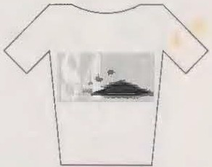
p4 _ WHITE
8
t shirt L t shirt XL

mothership back , the still always in 500 meters Hi:hee about to the Metepec
hill was standing.
think be n . ..
my all warmer Thanks to
goes on this Job on Headmaster colin Mackie,
Name : . _ first name : _

Road e : - - - ---- - - - -- - - - --- - -

As later known became - and how me mexican
the me this research at all allowed, the
ZIP location :
Country : _ I


air traffic controllers personally besili made - became the Space ship from Metepec five hours long , from 8:00 pm watch until short after 1.00 Watch, on to the radar screen located . It disappeared, as it in Zimbabwe I agree 10.00 watch
\'
f
4 6 mogazin 2000 / No. 119
children the Ariel school for
their standby to the Cooperation, as well as on Cynthia hind and prof John E. _ mack for their valuable work on to the Case.
© 1997 by MAGAZINE 2000
Alles rights reserved
Payment: cash on delivery 0 i m ahead D Credit Cards: D
(Amexco/Eurocard/DinersNisa)
NO _ Expiration : _

54 company , Gewerbestrasse _ _ _ 3 CH-8500 Frauenfeld _ _ _
Phone : 0041 52 720 67 27 facsimile 0041 52 720 67 3 7
e-mail s 4 _ compa n y @ b l uew i n . ch

